KICKSTARTER ANALYSIS

OVERVIEW OF PROJECT

Louise has written a play named “Fever”. She would like to have the play produced but needs to collect funding through the “Kickstarter” platform. There is a (somewhat) large set of data with a good bit of information about other projects that have used Kickstarter to gain funding for their ideas. Louise would like to have some analysis done on the data set to determine what makes a successful funding campaign in Kickstarter.

ANALYSIS

This analysis was completed by reviewing 2 sperate data patterns in order to come up with conclusions about the best time of year to launch Kickstarter funding campaign and the goal amounts that are most likely to be successful in completing the campaign meeting the requested funding goal.

Theater Outcomes by Launch Date created a pivot table that categorized the theater category and delineated the most successful funding outcomes in months over a series of years. Once the pivot table was completed, a line graph was extrapolated which very clearly showed the most successful launch month over time is May.

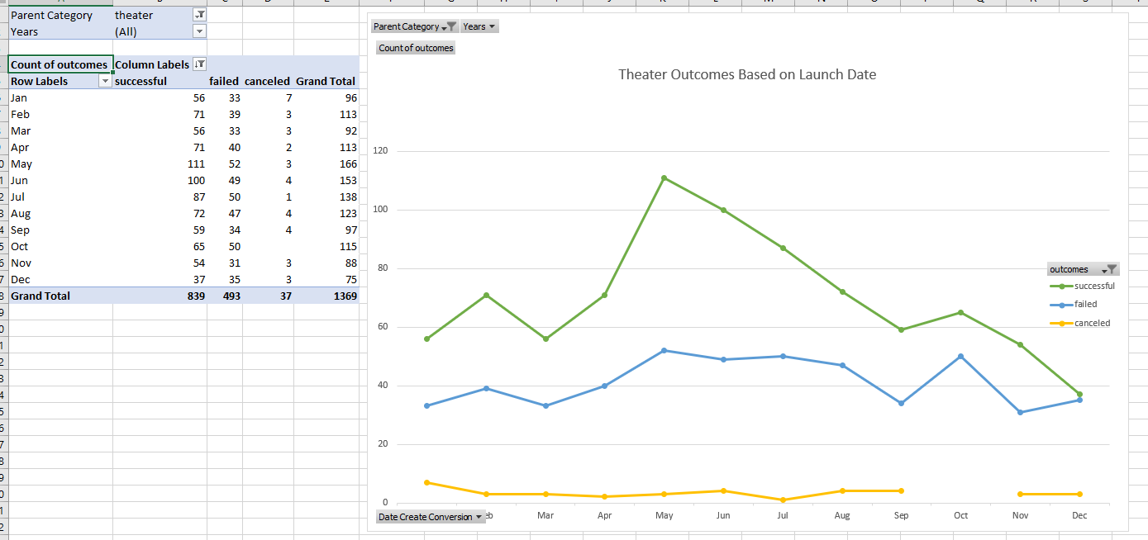

The Outcomes Based on Goals chart used the countifs function to determine if the goal was successful, failed and canceled for the plays subcategory, and the sum function along with a simple division was able to determine the percentage of successful, failed and canceled campaigns within a specified dollar range. A line graph was able to be created from the percentage data.

RESULTS:

- What are two conclusions you can draw about the Outcomes based on Launch Date?-- Outcomes are most likely to be successful when the launch date is in the 3rd quarter of the year.-- The peak launch month is in May.- What can you conclude about the Outcomes based on Goals?-- The highest percentage of successful outcomes are when the goal amount is less than $5000-- Another successful peak appears to be between $35,000 - $45,000.- What are some limitations of this dataset?-- There is not a lot of information about the demographics of the backers. - What are some other possible tables and/or graphs that we could create?-- We could see if there is a correlation between the "Staff Pick" and the number of successful campaigns.-- We could also determine if there is a correlation between "Spotlight" and successful campaigns.

